www.pmadata.org/stlr
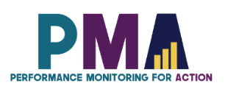

We invite you to use and adapt PMA STLR tools!

Whatever tool you discover and intend to try out, you will need to adapt these tools to your context.
This may include:
- Changing questionnaire question text: Some tools contain questions from our questionnaires (publicly available here), along with their numbering. Note that, in some cases, question numbering has changed across phases, but any questions cited in a tool use consistent numbering within that tool.
- Considering appropriate pronouns: We use female pronouns quite often, as PMA worked with female enumerators – and as a bonus, we are happy to use a feminine pronoun by default for a change!

TIP: Use our hashtag system!
As we used these tools across various country contexts, we developed a simple system of using hashtags as placeholders for information that will need to be updated based on the country, context, culture, and program.
For example, information in a tool that was country-specific is noted with the hashtag placeholder, #countryspecific – or possibly an even more specific placeholder like #districtlevel or #localpartner.
Information that required a change in date is noted with hashtags such as #todaysdate or #lastyear.
These hashtags allow those adapting the tool to use the Find&Replace function to quickly identify and update all instances of a hashtag within seconds.

Tips for Small Group Engagement

This list of tips and tricks for designing and facilitating small group activities during a training aims to ensure that every member of a small group is an active participant and learner. It can also serve as a helpful resource when facing challenges with inactive participants in small groups.

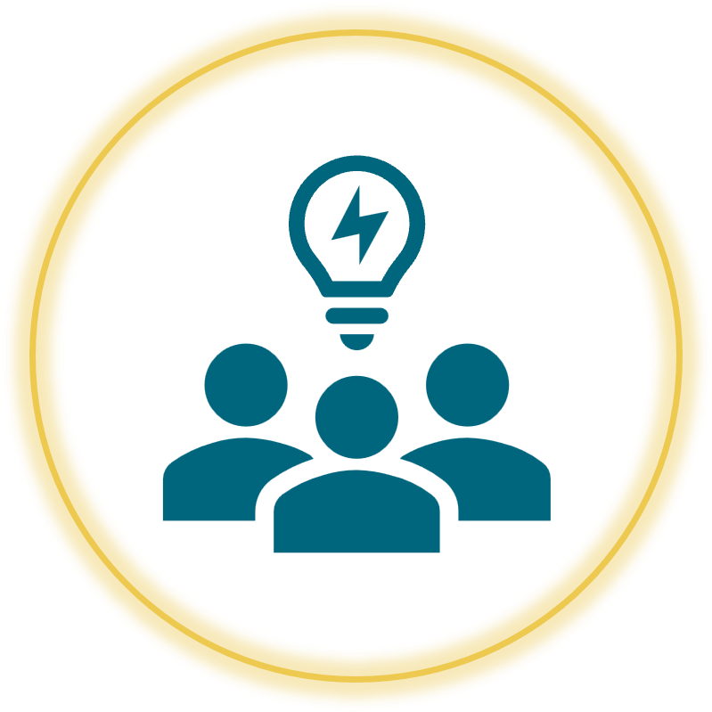

When adopting, adapting, and sharing this tool, please use this suggested citation:
“Tips for Small Group Engagement”, created by Sarah Nehrling, for PMA (Performance Monitoring for Action). Released June 2024. CC BY-NC 4.0.

Tips for Small Group Engagement

This list of tips and tricks for designing and facilitating a training session aims to ensure that every member of a small group is an active participant and learner. This list provides ideas to ensure that the design of the session is appropriate and also that enough time is built in for any of the tips that might require them It can also serve as a helpful resource when facing a problem with inactive participants in small groups.

When adopting, adapting, and sharing this tool, please use this suggested citation:
“Tips for Small Group Engagement”, created by Sarah Nehrling, for PMA (Performance Monitoring for Action). Released February 2024.
11 Tips and Tricks for
Keeping ALL Small Group Members Engaged and Learning

Breaking into small groups for task or project work is a great way to ensure that your workshops are participatory and that information shared in plenary can be converted to practice and a deeper understanding of the challenges of implementation. And YET, it seems nearly inevitable that a few people will decide to not participate in the work of their small groups, compromising not only their own learning but potentially also the collaborative spirit and desire to practice and learn of their group members.

What are some ways in which we can try to keep all small group members engaged and learning?

* Trying out ALL the following tips and activities at once could easily become overwhelming and time-consuming. We suggest identifying 1 to 4 practices that you feel are best suited to your group and which you are most comfortable introducing.

- Facilitators: Design Groups for Success: Take time beforehand to consider how best to divide people into groups. Should you pre-assign everyone to a group, trying to take into account a diversity of skills, experience, and opinions? Are there people who, for whatever relational reason, should not be in the same group? Could you ask each participant to first find a buddy and then, with the buddy, split into groups with people they do not know as well? What will work best for this specific group of people and this topic, and for your workshop and your small group work objectives?
- Facilitators: Circulate!: Your presence as you circulate around the room is essential during small group work. You need to be easily accessible when groups have questions for you and to be listening in on small group conversations to ensure that the instructions were clear and the groups are progressing in the right direction. But also, unfortunately, some participants will feel freer to disengage in group work if they feel like none of the facilitators are watching them.
- Consciously build a team spirit: Start with a fun group activity, such as creating a name and "flag" for the group or sharing silly information about one another (e.g. What is your favorite toothpaste brand?). A participant may feel more responsible toward a group to which s/he feels more familiar and somehow connected.
- Share strengths: Ask each participant to share with the others the specific skills that s/he is bringing to the group, in relation to the task at hand. This activity allows the individual to name and recognize their value-add and for others to call on them when this skill will be helpful in the task at hand.
- Set small group norms: While it does not make sense to spend a lot of time on small group norms for a workshop, it could be worth taking a minute or two in plenary to decide what others should be expecting from and contributing to their groups. Ideally, someone would add the norm that everyone should participate fully!
- Ask for computers and phones to be closed or focused on group work: While simply asking will not instantly result in everyone following the request, it may be enough to convince a few people. Especially if you are not asking groups to set small group norms, try to introduce this norm yourself - or remind others of it, if it is already part of the large group norms.
- Explain clearly what you do not want: When setting groups up for group work, tell a funny story about a group you have been in where someone (maybe you!) was the freeloader. Describe vividly what this freeloader did and how they acted, and especially others perception of them and their impact on the rest of the team. Ask that each participant be responsible for not being and not allowing a freeloader in their groups.
- Assign roles for each group member: Craft and then share specific roles and responsibilities for each member of the group. For example, there could be a reporter, a conversation-distributer (making sure everyone can contribute to the discussion), a task-master (keeping everyone focused on the task), a time-keeper (reminding others of the time limit, and giving time checks), a supplies manager (making sure the group has access to the necessary supplies), etc.
    - Require rotating responsibilities for report-backs: For each phase of the group work, plan time for a report-back in plenary. (This can be very quick! 30sec per group) In addition to or instead of assigning roles for each group member, require that the person reporting back for the team change every time; either the team can designate this person, or the facilitator can call on one group member at random.
- Experiment with cross-pollination: Sometimes, a group member may simply be bored with his or her own group. Give a few people a chance to walk around and see other groups during a "cross-pollination" period, where 1 or 2 members of each group can circulate and sit in on other groups' conversations for a few minutes, then returning to their original group and reporting back on what they saw or learned.
*** The riskier option is to have 1 or 2 members of each group move permanently to another group. We suggest that you leave this option aside unless or until you think that participants were not very well distributed into groups, in terms of skillsets, personalities, experiences, etc. In such an extreme case, redistribution could result in more balanced groups and potentially re-engage those who were disengaging because they felt like they did not fit in or they could not learn from or contribute to their group.
- Share research on the habits and methods of high-performing groups: For example, research by Anita Williams Woolley on "collective intelligence" suggests that the group reaches higher collective intelligence when its members are diverse, empathetic, and very actively sharing the conversation so that everyone participates. Who does not want to have higher collective intelligence?
- Give someone a way to opt out: In very extreme circumstances, there will be a group member who is not participating and cannot be convinced otherwise, but whose presence is a distraction to the members of his group who are working and learning. Try to casually approach this group member and explain that you noticed their lack of participation and are concerned about both the group's well-being and learning and their individual well-being and learning. Gently and non-judgmentally give two options: 1) stay sitting with the group and be an active participant, or 2) find a spot outside or on the edges of the room until the small group work session has ended. (The tone of your voice is super important here! You are not shaming; you are simply recognizing that they have challenges participating and trying to make this experience the best possible for everyone in the room.) While ideally they would choose Option 1, they might just go for Option 2. Sometimes we have something else going on - an emergency email from a boss, a hectic and loud evening with the family, a serious relational challenge with the group, who knows! - that will make us want to opt out of small group engagement on that particular day.

