www.pmadata.org/stlr
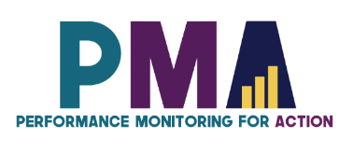

We invite you to use and adapt PMA STLR tools!

Whatever tool you discover and intend to try out, you will need to adapt these tools to your context.
This may include:
- Changing questionnaire question text: Some tools contain questions from our questionnaires (publicly available here), along with their numbering. Note that, in some cases, question numbering has changed across phases, but any questions cited in a tool use consistent numbering within that tool.
- Considering appropriate pronouns: We use female pronouns quite often, as PMA worked with female enumerators – and as a bonus, we are happy to use a feminine pronoun by default for a change!

TIP: Use our hashtag system!
As we used these tools across various country contexts, we developed a simple system of using hashtags as placeholders for information that will need to be updated based on the country, context, culture, and program.
For example, information in a tool that was country-specific is noted with the hashtag placeholder, #countryspecific – or possibly an even more specific placeholder like #districtlevel or #localpartner.
Information that required a change in date is noted with hashtags such as #todaysdate or #lastyear.
These hashtags allow those adapting the tool to use the Find&Replace function to quickly identify and update all instances of a hashtag within seconds.

Facilitator’s Card

This card acts as a handy reminder of the Top 7 elements that a facilitator should remember when leading a training. Unlock the key reminders that'll supercharge your sessions and keep participants engaged from start to finish.

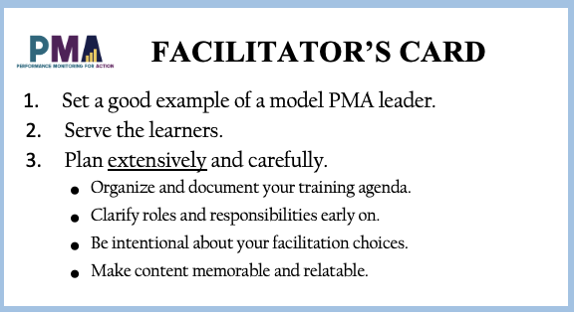

When adopting, adapting, and sharing this tool, please use this suggested citation:
“Facilitator’s Card”, created by Sarah Nehrling and PMA (Performance Monitoring for Action). Released June 2024. CC BY-NC 4.0.

ABOUT THE FACILITATOR’S CARD
This card is a brief summary of some of the most important elements that a facilitator should remember. We suggest that it be printed out, laminated (when possible), and distributed to those who will be facilitating a training – so, essentially, core staff before a supervisor training and supervisors before an RE training.
Why print and distribute this Card?
- As a reminder of the essential items of facilitation, given that a true preparation for new facilitation approaches will have much more info than this and the amount of info could be overwhelming, especially for someone who is relatively new to facilitation
- As a symbol of solidarity amongst facilitators, who are not just individuals each working on a session but are meant to support each other throughout the training
- As a reminder of the professional role that a facilitator plays, as someone who is entrusted with leading an activity whose success is crucial for the upcoming data collection
How to use this Card?
- As a quick review tool: Ask the facilitators to keep this card in their pocket and review it regularly during the training to see if they are facilitating well. This review can be used for individual debriefs with facilitators who are facing challenges, and/or as a group debrief or reflection activity.
- As a “coin check” challenge: In a “coin check” challenge, the person distributing the cards (lead facilitator?) challenges everyone to keep this card on their person at all times – both throughout the training and afterward. Anyone who can produce their card when requested by the lead facilitator, even in the months and years to come, will be entitled to a prize!

How to print the Card
By printing the following page back-to-back, you will have a double-sided card. Alternatively, you can print one-sided, cut lengthwise, and then fold each strip in half and glue the two sides of the folded strip together.
Feel free to change the logo and colors to those of your country team.
When possible, print in color and laminate the card so that it is professional and durable.

Note:
The card mentions “ACE” feedback. The ACE Model for giving feedback that suggests we provide three distinct types of feedback: appreciation, coaching, and evaluation

FACILITATOR’S CARD  - Set a good example of a model PMA leader.  - Serve the learners.  - Plan extensively and carefully.  - Organize and document your training agenda.  - Clarify roles and responsibilities early on.  - Be intentional about your facilitation choices.  - Make content memorable and relatable. | - Be alert and communicative during the session.  - Observe actively what is going on in the room.  - Communicate with your co-facilitation team.  - When in doubt, ask for clarification.  - Make participants feel heard.  - Give feedback regularly, of all three types (ACE).  - Be ready to adapt.  - Lose time only to gain time.  - Expect the unexpected.  - Reflect, debrief, improve.  - Smile!
FACILITATOR’S CARD  - Set a good example of a model PMA leader.  - Serve the learners.  - Plan extensively and carefully.  - Organize and document your training agenda.  - Clarify roles and responsibilities early on.  - Be intentional about your facilitation choices.  - Make content memorable and relatable. | - Be alert and communicative during the session.  - Observe actively what is going on in the room.  - Communicate with your co-facilitation team.  - When in doubt, ask for clarification.  - Make participants feel heard.  - Give feedback regularly, of all three types (ACE).  - Be ready to adapt.  - Lose time only to gain time.  - Expect the unexpected.  - Reflect, debrief, improve.  - Smile!
FACILITATOR’S CARD  - Set a good example of a model PMA leader.  - Serve the learners.  - Plan extensively and carefully.  - Organize and document your training agenda.  - Clarify roles and responsibilities early on.  - Be intentional about your facilitation choices.  - Make content memorable and relatable. | - Be alert and communicative during the session.  - Observe actively what is going on in the room.  - Communicate with your co-facilitation team.  - When in doubt, ask for clarification.  - Make participants feel heard.  - Give feedback regularly, of all three types (ACE).  - Be ready to adapt.  - Lose time only to gain time.  - Expect the unexpected.  - Reflect, debrief, improve.  - Smile!
FACILITATOR’S CARD  - Set a good example of a model PMA leader.  - Serve the learners.  - Plan extensively and carefully.  - Organize and document your training agenda.  - Clarify roles and responsibilities early on.  - Be intentional about your facilitation choices.  - Make content memorable and relatable. | - Be alert and communicative during the session.  - Observe actively what is going on in the room.  - Communicate with your co-facilitation team.  - When in doubt, ask for clarification.  - Make participants feel heard.  - Give feedback regularly, of all three types (ACE).  - Be ready to adapt.  - Lose time only to gain time.  - Expect the unexpected.  - Reflect, debrief, improve.  - Smile!

